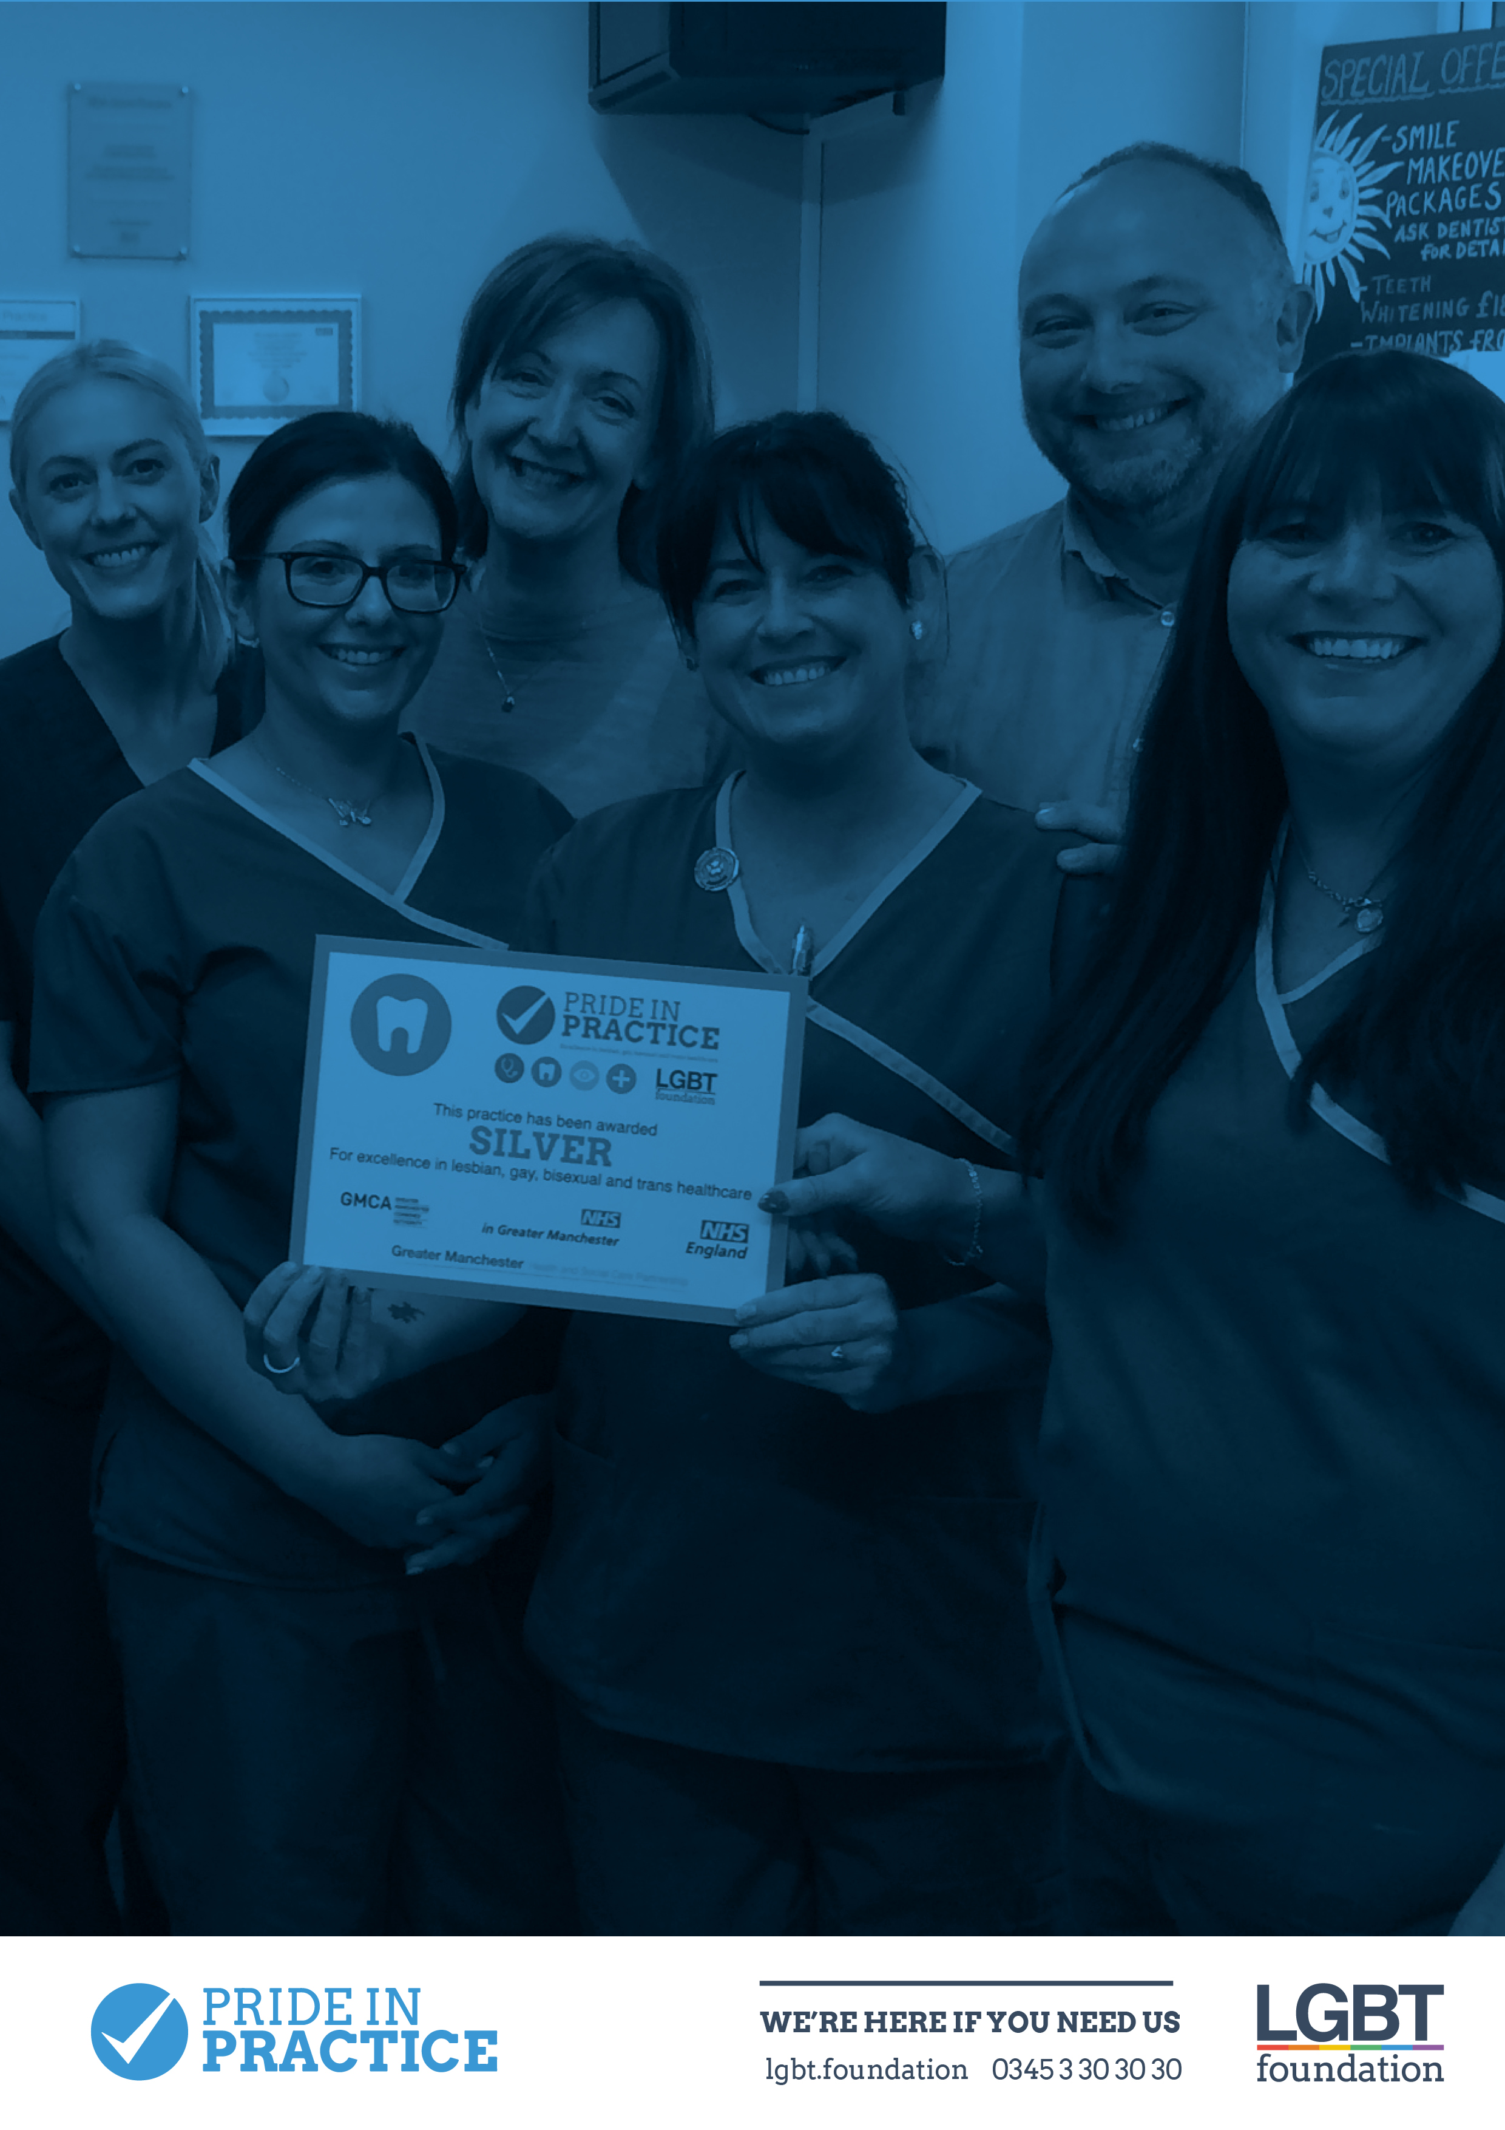
This document includes some key events and healthcare campaigns throughout 2020. LGBT people face disproportionate health inequalities compared to the general population. Therefore, national and local healthcare campaigns are an ideal opportunity to make patients aware of possible health risks, local support services and further information and signposting.

This is by no means an exhaustive list but could be used as a springboard within practice. If you have any further questions, please contact pip@lgbt.foundation

Dry January – many social events involve alcohol, but what if people want to stop or reduce their drinking? Are you aware of alcohol support groups at LGBT Foundation? Or social events such as Queers Without Beers?
1st-31st January
https://alcoholchange.org.uk/get-involved/campaigns/dry-january
Fact: One in six LGBT people say they drank alcohol every day over the last year

Cervical Cancer Prevention Week – an opportunity to raise awareness of HPV and preventions (e.g. vaccinations, safer sex, awareness of risks for contracting and transmitting etc.)
20th – 26th January
https://www.jostrust.org.uk/get-involved/campaign/cervical-cancer-prevention-week
Fact: A survey found that 37% of lesbian and bisexual women in the North West of England had been misinformed that they didn’t need a cervical screen because of their sexual orientation.

LGBT History Month – an opportunity to raise awareness of LGBT healthcare, possible risks and local services and supports for LGBT people
1st – 29th February

World Cancer Day – a good chance to promote awareness of cancers such as prostate, anal and breast/chest, which have high prevalence in LGBT Communities
4th February
https://www.worldcancerday.org/
Fact: 90% of gay and bisexual men have never spoken with a healthcare professional about prostate cancer

Eating Disorder Week – signpost support services for people suffering with eating disorders
2nd – 8th March
https://www.beateatingdisorders.org.uk/edaw
Fact: 1 in 5 gay and bisexual people have problems with their weight or eating – this is 4 times higher than the general population

Lesbian, Bisexual and Trans (LBT) Women’s Health Week – a chance to make LBT women aware of risk factors more prevalent within LBT communities e.g. higher prevalence of substance use, misinformation regarding sexual health testing, higher prevalence of depression
9th-13th March
https://nationallgbtpartnership.org/lbtwh/
Fact: Less than half of lesbian and bisexual women have been screened for sexually transmitted infections

Stress Awareness Month – do patients know that they can access mainstream and LGBT specific services (e.g. counselling)?
1st – 30th April
https://lgbt.foundation/talkingtherapies
Fact: 52% of young LGBT people reported self-harm either recently or in the past – this number is over double that of the general population.

Cervical Screening Awareness Week – another opportunity to raise awareness of the need for cervical screening among lesbian and bisexual women and trans men with cervixes
15th – 21st June
https://www.jostrust.org.uk/get-involved/campaign/cervical-screening-awareness-week
Fact: 40.5% of lesbian, gay and bisexual women have been incorrectly informed by healthcare professionals that they don’t need a cervical smear

Sexual Health Week – did you know that LGBT Foundation offers Rapid HIV Testing and Full Sexual Health Screenings for LGBT people every week? Sexual Health Week can be a great time to remind people the importance of testing and testing regularly
26th-22nd September
https://lgbt.foundation/testing
Fact: Trans women are 49 times more likely to be HIV positive than the general population worldwide

Stoptober – are patients aware of any quit smoking groups for LGBT people? Are GPs aware of smoking prevalence rates among LGBT communities?
1st-28th October
https://smokefree.gov/lgbt-and-smoking
Fact: 30.5% of bisexual women smoke compared to only 17.5% of straight women

National HIV Testing Week – an opportunity to promote HIV testing through signposting to local GUM clinics, rapid HIV testing at LGBT Foundation or making patients aware of HIV testing available at your practice
14th-20th November
https://www.startswithme.org.uk/
https://lgbt.foundation/testing
Fact: The most recent report from Public Health England lists Manchester’s HIV prevalence rate as 6.21 per 1000 people – this is over 3 times the national average

Trans Awareness Week – an opportunity to make patients aware of the health inequalities that trans people face, remind patients that they can update their name and gender marker at your practice or simply a chance to promote local services such as LGBT Foundation’s trans Manchester events, the Proud Trust for young trans people or Mermaids for families of trans and non-binary children
13th-19th November

On the lead-up to Trans Day of Remembrance, internationally we mark Trans Awareness Week. It is a time for raising the visibility of trans people and addressing the issues these communities still face. Organisations across the country typically host a wide range of events for trans and non-binary people and their allies.

Transgender Day of Remembrance (TDOR)
November 20th
Since 1999, TDOR has been observed to memorialise those who have been murdered by transphobia. It can also be used to recognise ongoing negative effects of transphobia. TDOR can be a difficult time for many trans people and some choose not to observe it. To offer a more positive celebration of trans people, Trans Day of Visibility (TDOV) was founded in 2010.

World Aids Day – Although a week after HIV testing week, it could be a good time to inform patients about PrEP and PEP
1st December
https://www.worldaidsday.org/
https://www.prepimpacttrial.org.uk/
Fact: PrEP reduces HIV infections among gay men by 86%

For more information on national campaigns throughout the year, please go to: https://www.nhsemployers.org/retention-and-staff-experience/health-and-wellbeing/understanding-your-data/calendar-of-national-campaigns-2018

